Interface-Engineered MXene/Layered Double Hydroxide Heterostructure
for Dopamine Sensing

Ayush Gadpayle,^{1,5,6} Hemil Marviya,¹ Yi Yang,¹ , Jean G. A. Ruthes,^{5,6} Peter Rolf Burger,^{5,6} Krutarth Kamath,¹ Volker Presser,^{5,6,7} Babak Anasori,^{1,3} Arun Kumar Mannodi¹ and Lia Stanciu^{1,2,4*}

- School of Materials Engineering, Purdue University, 701 West Stadium Ave., West Lafayette, IN, 47907, USA
- School of Biomedical Engineering, Purdue University, 206 S Martin Jischke Dr, West Lafayette, IN, 47907, USA
- School of Mechanical Engineering, Purdue University, 701 West Stadium Ave., West Lafayette, IN, 47907, USA
- Bindley Bioscience Center, Purdue University, 1203 W State St, West Lafayette, IN, 47907, USA
- INM - Leibniz Institute for New Materials, D2 2, 66123, Saarbrücken, Germany
- Department of Materials Science & Engineering, Saarland University, Campus D2 2, 66123, Saarbrücken, Germany
- saarene, Saarland Center for Energy Materials and Sustainability, Campus C4 2, 66123 Saarbrücken, Germany

* Corresponding authors’ email: lstanciu@purdue.edu (L. Stanciu)

Keywords:
MXene (Ti₃C₂T_{x}); Layered double hydroxide (Ni₂FeMn-LDH) ; Dopamine Sensor

Abstract
Layered double hydroxides (LDHs) are attractive for electrochemical sensing because of their electroactive and hydroxyl-rich surfaces. However, their practical sensing performance is often limited by poor electrical conductivity. In contrast, Ti₃C₂T_{x} MXenes exhibit high electrical conductivity and hydrophilic surface chemistry, but they can lack sufficient analyte-specific adsorption sites. Here, we develop a Ni_{0.5}Fe_{0.25}Mn_{0.25} layered double hydroxide/Ti₃C₂T_{x} MXene hybrid composite (NFM-MX) for dopamine sensing, where Ti₃C₂T_{x} serves as a conductive scaffold, and NFM-LDH provides hydroxyl-rich molecular recognition sites. Density functional theory calculations reveal that dopamine adsorbs moderately on mixed-terminated Ti₃C₂T_{x}, with adsorption energies around -0.6 eV. In contrast, NFM-LDH enables significantly stronger dopamine adsorption, with the most stable configuration reaching -1.5 eV. The enhanced adsorption on NFM-LDH proceeds through an acid-base-type adsorption process, where catechol deprotonation forms a catecholate-like species stabilized by multiple cooperative hydrogen-bonding interactions with the hydroxylated LDH surface. Furthermore, the charge redistribution at the NFM-MX interface leads to the formation of an interfacial dipole and electronic coupling across the van der Waals contact, while preserving the intrinsic properties of both components. Electrochemical measurements demonstrate improved dopamine sensing performance for the NFM-MX electrode, achieving a detection limit of 0.109 µM under optimum conditions. Competitive discrimination against common interference molecules was observed.

Introduction
Dopamine (DA) is an important catecholamine neurotransmitter that plays a critical role in motor control, cognition, motivation, emotions, memory, and neurochemical signaling. Abnormal dopamine concentrations are associated with several neurological and psychiatric disorders, including Parkinson’s disease, schizophrenia, attention deficits, and other neurodegenerative conditions.^{1, 2} Therefore, the development of rapid, sensitive, and reliable dopamine detection platforms is important for point-of-care healthcare applications.³ Conventional analytical methods such as chromatography,⁴ UV-vis spectroscopy,^{5, 6} and colorimetry,^{7, 8} can provide accurate dopamine quantification. However, they often require advanced instrumentation and complex sample preparation.⁹ In contrast, electrochemical sensing offers a rapid, low-cost, and portable route for dopamine detection because DA is intrinsically electroactive and can be oxidized to dopamine-o-quinone through a catechol-based proton-coupled electron-transfer process (PCET).^{10, 11} Despite these advantages, selective non enzymatic electrochemical detection of DA remains challenging because under physiological conditions, biological fluids contain several electroactive interferents, especially ascorbic acid (AA) and uric acid (UA), which can coexist at higher concentrations and oxidize in similar potential regions,¹² because the oxidation signals of DA, AA, and UA often overlap, resulting in poor peak resolution, low selectivity, and inaccurate dopamine quantification.
Nanostructured transition-metal compounds,¹³ including metal oxides,^{14, 15} hydroxides,¹⁶ sulfides,^{17, 18} conducting polymers,¹⁹ carbon-based materials,²⁰ metal-organic-framework-derived composites²¹ and two-dimensional hybrid composites have been investigated as non-enzymatic dopamine sensing platforms. Among these, layered double hydroxides (LDHs) are attractive because of their tunable metal composition, large surface area, and their hydroxyl-rich layered structure. The brucite-like LDH framework consists of edge-sharing metal hydroxide octahedra,²² which provides abundant surface hydroxyl groups for interaction with analytes. This surface chemistry is particularly relevant for dopamine because DA contains catechol hydroxyl groups and an amine functionality, both of which can participate in hydrogen bonding and interfacial charge polarization. Hydroxylated surfaces are known to stabilize O/N-containing organic molecules through multiple surface-adsorbate hydrogen bonds, and cooperative hydrogen bonding can significantly strengthen adsorption.²³ Catechol-containing molecules can further interact with metal oxide or hydroxylated surfaces through hydrogen bonding, proton transfer, and catecholate-type surface complexation.^{24, 25} Therefore, LDHs can potentially serve as molecular recognition layers for dopamine adsorption. However, their poor intrinsic electrical conductivity and limited active surface area due to aggregation often limit fast electron transport and restrict their practical electrochemical sensing performance.²⁶
To overcome the conductivity limitations of electroactive metal hydroxides, several strategies have been explored, including coupling them with conductive materials such as graphene,²⁷ reduced graphene oxide,²⁸ carbon nanotubes,²⁹ and hybrid conductive frameworks.³⁰ These conductive additives can improve electron-transfer kinetics, increase accessible surface area, and provide better electrode/electrolyte contact, thereby enhancing the electrochemical response. Similar strategies have also been applied in dopamine sensing. However, many of these approaches primarily improve conductivity or surface area, while the molecular-level role of analyte adsorption and interfacial charge transfer remains less clearly understood.
Two-dimensional Ti₃C₂T_{x} MXene has emerged as a promising conductive electrode material because of its metallic conductivity, hydrophilic surface chemistry, large surface area, and tunable surface terminations such as -O, -OH, and -F.^{31, 32} However, Ti₃C₂T_{x} surfaces can lack sufficient analyte-specific adsorption sites, and the local distribution of surface terminations strongly influences dopamine interaction with Ti₃C₂T_{x}. Recent density functional theory (DFT) studies have further shown that dopamine can adsorb on Ti₃C₂-based MXene surfaces and that the adsorption behavior is strongly influenced by surface modification. For example, dopamine adsorption on pristine Ti₃C₂ was reported to be much stronger than on hydroxyl-terminated Ti₃C₂(OH)₂, while Ti-vacancy defects substantially enhanced dopamine binding.³³ These findings highlight that the local surface chemistry of Ti₃C₂ plays a decisive role in DA adsorption and that surface termination can significantly weaken or modify DA-MXene interactions. As a result, MXene alone may provide efficient electron transport but only moderate dopamine anchoring. Coupling MXene with an adsorption-active LDH is therefore a rational strategy to overcome the limitations of both materials: MXene can act as a conductive scaffold, while LDH can provide hydroxyl-rich recognition sites for dopamine.
Herein, we report a Ni_{0.5}Fe_{0.25}Mn_{0.25} layered double hydroxide/Ti₃C₂T_{x} MXene hybrid composite as a non-enzymatic electrochemical platform for dopamine sensing. The hybrid structure is designed to combine the hydroxyl-rich molecular recognition capability of NFM-LDH with the conductive charge-transport pathway of Ti₃C₂T_{x} MXene. Electrochemical sensing measurements are integrated with first-principle DFT calculations to establish a structure-property mechanism relationship. DFT results reveal that dopamine adsorbs moderately on mixed-terminated Ti₃C₂T_{x} surfaces, whereas NFM-LDH enables significantly stronger adsorption through cooperative hydrogen bonding and proton-transfer-assisted catechol activation. Charge-density difference, total projected density of states, and Bader analyses further show interfacial charge redistribution within the NFM-MX heterostructure and strong local charge polarization during dopamine adsorption on NFM-LDH. This work provides a mechanistic basis for designing MXene/LDH heterostructures as electronically coupled and adsorption-active platforms for dopamine and related catecholamine sensing.

Experimental Section

Materials
Nickel nitrate hexahydrate (Ni(NO₃)₂ ·6H₂O, Sigma-Aldrich), Manganese chloride (MnCl₂ ·4H₂O, certified A.C.S, Fisher Scientific), Iron (III) chloride hexahydrate (FeCl₃ ·6H₂O, 99+%, Arcos Organics), sodium carbonate (Na₂CO₃, powder, ≥99.5%, ACS reagent), Sodium hydroxide (NaOH, Sigma-Aldrich, ≥99.5%), ethanol (EtOH), hydrochloric acid (HCL), dopamine-hydrochloride (DA, ≥98%, Sigma-Aldrich), uric acid (UA, ≥99%, crystalline, Sigma-Aldrich), L-ascorbic acid (99%, Sigma-Aldrich), citric acid (Sigma-Aldrich, ≥99.5%), D-(+)-glucose (BioUltra, anhydrous, ≥99.5%), potassium chloride(KCl, SigmaUltra, ≥99.0%, Sigma-Aldrich), and distilled water (D) were used for synthesis.
MXene synthesis section missing :- work in progress
Synthesis of Ni₂MnFe-LDH. Ni₂MnFe-LDH (NFM) was synthesized using a coprecipitation method. Briefly, Ni(NO₃)₂ ·6H₂O (1.45 g), MnCl₂ ·4H₂O (0.50 g), FeCl₃ ·6H₂O (0.68 g) were dissolved in 100 mL of DI water under magnetic stirring. The precursor was then heated to +90 °C on a hot plate under continuous stirring at 300 rpm. Simultaneously, a mixed alkaline solution was prepared from NaOH (0.5 M) and Na₂CO₃ (0.1 M) and then added slowly to the metal precursor solution under stirring until the pH reached 8. The resulting suspension was further aged for 1 h under stirring at 90 °C. For pristine NFM-LDH, the suspension was washed four times with DI water and twice with ethanol, followed by drying at 60 °C in a vacuum oven. For composite preparation, the unwashed NFM-LDH suspension was retained and used directly to preserve the colloidal state of the LDH particles.
Synthesis of Ni₂MnFe-LDH/Ti₃C₂T_{x} MXene. The optimized NFM-LDH/Ti₃C₂T_{x} MXene (NFM-MX) composite was prepared by mixing exfoliated Ti₃C₂T_{x} MXene dispersion (0.5 mg mL⁻¹) with the freshly prepared unwashed NFM-LDH suspension at a volume ratio of 80:20, respectively. The mixture was stirred for 1 h to promote interaction between the MXene flakes and NFM-LDH. The resulting NFM-MX composite was then washed repeatedly by centrifuging for 10 min at 5000 rpm with DI water and ethanol to remove residual free ions and unreacted salts. The suspension was subsequently sonicated for 30 min to improve dispersion and facilitate electrostatic self-assembly between negatively charged Ti₃C₂T_{x} MXene sheets and positively charged NFM-LDH.

Material Characterizations
Scanning electron microscopy (ZEISS GEMINI 500) was used to analyze the morphologies of the nanostructures. The same instrument is equipped with energy-dispersive X-ray spectroscopy (EDX) detector from Oxford instruments which was used to further utilize to examine the materials elemental distributions. An accelerating voltage of 1 kV and 5 kV was used for imaging and EDX spectroscopy respectively. The crystal structure and phase of the materials was analyze using the D8 Discover diffractometer (Brucker AXS) with Cu Kα radiation (λ = 1.5406 Å, 40 kV, 40 mA). A Göbel mirror was used to focus the X-ray beam to an approximately 1 mm spot size, and diffraction signals were collected with an EIGER2 two-dimensional detector. Patterns were recorded over a 2θ range of 2° to 80° in continuous mode using a step size of 0.019° and a counting time of 1 s per step. Samples were mounted on a 0.5 mm deep glass holder, and the collected diffraction patterns were normalized by intensity for comparison.

Electrode preparation and electrochemical characterization
To understand the interfacial charge transfer and electrochemical response of synthesized materials, electrode was prepared using coating method. The electrode consisted of synthesized active material (80 mass%), Super C65 (10 mass%) and polyvinylidene fluoride (10 mass%) were grounded and mixed in mortar and then N-methyl-2-pyrrolidone (NMP) was injected dropwise to make the uniform slurry. It was further milled using speed mixer at 800 rpm for 30 minutes. Then, the electrode slurry was cast onto the graphite foil using laboratory doctor blade of 200 µM film thickness. The film was dried in vacuum oven at 60 °C for 24 h and then 12 mm diameter circular electrodes were punched out. The electrochemical performance of the resulting electrodes was evaluated in PEEK cells with three electrodes set up of oversized activated carbon (YP80F) which was prepared by mixing activated carbon and PTFE binder in a 90:10 mass ratio in ethanol, rolling the paste to 600 µm thickness, and vacuum-drying overnight at 80 °C which served as counter electrode and Ag/AgCl as reference electrode in 1 M NaCl as the electrolyte. Cyclic Voltammetry (CV) and Electrochemical Impedance spectroscopy (EIS) performance measurements were conducted using VSP300 potentiostat/galvanostat (Bio-Logic). The CV measurements were conducted over a range of -0.3 V to 0.5 V at 5 to 100 mVs⁻¹ .Electrochemical impedance spectroscopy (EIS) was measured in the frequency range of 100 kHz to 1 mHz at open circuit potential.
Dopamine Sensing performance evaluated by modifying the commercial screen-printed electrode. Commercially available screen-printed electrodes (SPE) were purchased from Micrux Technologies (D2PE) for better experimental convenience and reproducibility. Sensing electrodes were fabricated by modifying the carbon working electrode by drop casting 2 µL of prepared suspension NFM-MX onto the working area of 2.3 mm² and drying under ambient conditions. The integrated Ag/AgCl and carbon electrodes served as the reference and counter electrodes, respectively, forming a three-electrode configuration. Cyclic voltammetry (CV) and differential pulse voltammetry (DPV) measurements were carried out in 0.1 M phosphate-buffered saline (PBS) using a Sensit BT potentiostat (PalmSens). For comparison, electrodes modified with MX, NFM-LDH, and NFM-MX were prepared using the same drop-casting procedure.

DFT Computational Methodology
To get the atomic scale details of the interface between MXene and LDH, first principal density functional theory (DFT) calculations were performed to investigate the adsorption behavior and electronic interactions of dopamine (DA) on MXene and layered double hydroxide (LDH) surfaces. All calculations were carried out using the Vienna Ab initio Simulation Package (VASP) within the framework of the projector augmented wave (PAW) method.^{34, 35} The exchange-correlation interactions were described using the Perdew Burke Ernzerhof (PBE) functional within the generalized gradient approximation (GGA).³⁶ A plane-wave energy cutoff of 500 eV was employed for all calculations. Geometry optimizations were performed using a Γ-centered Monkhorst-Pack k-point mesh of 1 × 1 × 1, while a denser 3 × 3 × 1 k-point grid was used for static calculations, including density of states (DOS) and charge density difference (CDD) analyses. All atomic positions and lattice parameters were relaxed until total energy converged to within 1 × 10⁻⁶ eV, and the residual forces on each atom were less than 0.02 eVÅ⁻¹. To eliminate interactions between periodic images, a vacuum layer of approximately 15 Å was introduced along the surface in the normal direction. Van der Waals interactions, which are important for accurately describing adsorption phenomena, were included using the DFT-D3 method with Grimme’s correction.³⁷ The Adsorption Energies (E_{ads}) and CDD were calculated using the equations (1) and (2), respectively.
E_{ads} = E_{DA + surface} - (E_{surface} + E_{DA}) (1)
Where E_{ads} is the total energy of the dopamine-adsorbed system, E_{surface} is the energy of the pristine surface, and the energy of the isolated dopamine molecule. A negative absorption of energy indicates energetically favorable adsorption.
Charge transfer was quantified using Bader charge analysis.³⁸ The charge density difference (CDD) was evaluated to visualize electron redistribution upon adsorption, using:
Δρ = p_{tot} - (ρ_{surface} + ρ_{DA}) (2)
where p_{tot} is the total charge density of the combined system and ρ_{surface} and ρ_{DA} correspond to the charge densities of the isolated surface and dopamine molecule, respectively. Positive and negative regions in the CDD represent electron accumulation (Yellow color) and depletion (Cyan color), respectively.

Results and discussion

Material characterization
Figure 1 presents an overview of our synthesis process. The successful preparation of NFM-MX is verified from structural analysis. The crystal structure was investigated by X-ray diffraction technique. Figure 2A shows the X-ray diffractogram of the MXene freestanding film which shows the characteristic of (002) peak at 2θ = 6.02°, NFM shows the diffractions at 2θ values of 11.22°, 22.64°, 34.28°, 60.42° which can be assigned to (003), (006), (012), and (110) reflections respectively. This matches well with diffraction peaks of hydrotalcite type NiFe-LDH (JCPDS 51-0463).³⁹ In case of NFM-MX, NFM characteristics peak are retained in the XRD pattern. However, the characteristic (002) diffraction peak of Ti₃C₂T_{x} MXene becomes weaker and shifts slightly toward lower 2θ values. This can be attributed to NFM-LDH preventing Ti₃C₂T_{x} flakes restacking, promoting the increase in interlayer spacing and partially overlapping the NFM diffraction features due to low intensity.^{40, 41}
The morphology of the samples was observed by scanning electron microscopy (SEM) ZEISS GEMINI 500 equipped with an EDS detector from Oxford Instruments. As shown in Figure 2B, NFM-LDH exhibits typical dense aggregated nanosheet layered morphology. The morphology of NFM-MX is shown in Figure 2C which shows wrinkled and interconnected sheets like morphology in which NFM-LDH is decorated mostly on the edges of the MXene flakes. This architecture is expected to have synergistic effect of enhancing electrochemical performance by providing more active sites of LDH and MXene as conductive scaffold, suppressing the restacking of MXene sheets and facilitating efficient electrolyte and charge transport across the NFM-MX interface. The elemental distribution of NFM-MX was evaluated by energy dispersive X-ray spectroscopy (EDX). The EDX spectra of NFM-MX seen in Supporting Information, Figure S1 shows the characteristic peaks of Ti, Ni, Fe, and Mn confirming the
presence of LDH and MXene in hybrid structure. Figure 2D-I elemental maps clearly revealed the presence of Ti and C from MXene and Ni, Fe and Mn from LDH containing hybrid and their broadly distributed elemental signals support the successful integration of LDH and MXene component within the composite.

To understand the electronic interaction at the NFM-MX interface, charge density difference (CDD), projected density of states (PDOS), planar-averaged electrostatic potential, and Bader charge analyses were performed. The combined results consistently indicate significant interfacial charge transfer from LDH to MXene, leading to interface dipole formation. The optimized atomic structure of NFM-MX is shown in Figure 3A, MX and NFM are given in Supporting information, Figure S2. In Figure 3B, the CDD isosurface shows that charge redistribution is primarily localized at the NFM-MX interface rather than in the bulk regions of either material, indicating that the electronic interaction is interfacial in nature. Electron depletion is mainly observed on the NFM side near the interfacial surface hydroxyl sides, while electron accumulation is observed on the MX side, particularly near surface oxygen/hydroxyl groups. The direction and magnitude of charge transfer are further quantified using Bader charge analysis. The results show a net charge transfer of 0.015 e⁻ Å⁻² from NFM to MX for the normalized simulated supercell area, indicating that the NFM-LDH layer becomes relatively electron depleted, whereas the MXene layer becomes electron enriched upon interface formation. This charge redistribution leads to the formation of an interface dipole and Van der Waals electronic coupling between the two materials.
To examine the nature of this interaction, a two-dimensional ELF map was generated for a plane (100) intersecting the NFM-MX contact region (Figure 3C). As shown in Supporting Information, Figure S3, The ELF maps of Ti₃C₂T_{X} MXene and NFM-LDH reveal distinct electron-localization behavior. In Ti₃C₂T_{x} MXene, strong localization is mainly observed around the surface terminations, while the Ti-C framework exhibits continuously more delocalized electronic character. In contrast, NFM-LDH shows pronounced electron localization only around surface hydroxyl group and metal centers show low localized electron density which is consistent with its poor intrinsic conductivity. No continuous high-ELF region is evident across the NFM-MX interface. MXene and LDH electronic localization remain intact without changing its intrinsic electronic properties. Interaction is consistent with oxygen/hydroxyl-mediated (Ti-O-H…O) electrostatic attraction between the NFM-LDH and MX surfaces.
The electronic states associated with interface formation were further evaluated using density of state (TDOS) and projected density of state (PDOS) analyses. As shown in Figure 3D, The MX Ti 3d finite states retains near Fermi-level (E_{F}) region, supporting the role of MXene as the conductive pathway, while NFM displays spin polarized states near E_{F}, which can be associated with transition-metal d states contributions. However, NFM-MX shows the different distribution of transitional metal d orbitals coexisting with Ti 3d states (Supporting Information, Figure S4). This behavior suggests interface-induced electronic modulation following heterostructure formation.
The planar-averaged electrostatic potential profiles were calculated to evaluate the surface work functions(Ф) and interfacial electrostatic asymmetry of the NFM-MX heterostructure, as shown in Figure 3E. The surface work function (Ф) was determined using Ф = E_{vacuume} – E_{fermi}, where E_{vacuume} is the vacuum energy level and E_{fermi} is fermi level energy. The isolated Ti₃C₂T_{x} MXene slab exhibits relatively high surface work functions of 5.33 eV, consistent with its metallic and electron-accepting character. In contrast, the isolated NFM-LDH slab shows much lower surface work functions of 1.58 eV. NFM-MX heterostructure exhibits two distinct vacuum levels, corresponding to apparent surface work functions of 5.08 eV for the MXene-exposed side and 1.78 eV for the NFM-exposed side. The shift in surface work function compared with the isolated components indicates vacuum-level modification and interfacial dipole formation at the NFM-LDH/MXene interface. This behavior is consistent with the CDD and Bader charge analyses, which reveal interfacial charge redistribution with electron accumulation toward the MXene side (0.015 e⁻ Å⁻²). The resulting built-in electrostatic field can promote directional charge transport from the dopamine-active NFM-LDH domains toward the conductive Ti₃C₂T_{x} MXene scaffold, thereby contributing to the enhanced electrochemical response of the NFM-MX electrode.

Electrochemical Characterization

Dopamine sensing performance
The DA current responses of different electrodes toward 1 µM DA in 0.1 M PBS were compared to optimizing the NFM-MX ratio. As shown in Figure 4A, pristine MXene and NFM-LDH exhibited comparable DA currents, suggesting that neither MX conductivity alone nor NFM active sites alone are sufficient to maximize the dopamine oxidation response.
After coupling NFM-LDH in different vol% with MX, the DA peak current increased significantly with increasing NFM, confirming the synergistic contribution of the two components. The enhanced response can be attributed to the combination of structural and interfacial effects. NFM-LDH on MXene sheets can suppress MXene restacking and create a more open, porous hybrid architecture, improving electrolyte penetration and exposing a larger number of accessible active sites. Among all the hybrids, the current response increased from 10% to 30% NFM-MX, with 20% and 30% NFM-MX showing similarly high peak currents. Although 30% NFM-MX gave a slightly higher average current, 20% NFM-MX was selected as the optimized composition because it provided a strong and reproducible DA response while maintaining a balanced interface between LDH active sites and conductive MXene pathways. Further increase in NFM loading may introduce or open additional active sites, but it can also partially block MX conductive channels or promote local aggregation. To evaluate the sensing performance toward dopamine (DA), differential pulse voltammetry (DPV) measurements were carried out within the potential window of -0.4 to +0.25 V (vs. Ag/AgCl) in 0.1 M phosphate-buffered saline (PBS, pH 7.0). As shown in Figure 4B, the DA oxidation current increases progressively with successive additions of DA in the concentration range of 0 to 1 µM. DA oxidation on bare carbon SPE electrode shows lower current response and poor concentration dependent calibration than prepared material as can be seen in Figure S5A. A linear relationship between current and DA concentration was provided in Figure 4C within the range of 0-1 µM, with a correlation coefficient (R²) of 0.99 and with calculated limit of detection (LOD) of 0.109 µM using the formula LOD = 3σ/S, where σ is the standard deviation of black signal in PBS and S is the slope of calibration curve.
To get the mechanistic insight into the DA adsorption mechanism, adsorption energies were calculated using DFT. Supporting Information, Figure S6A shows the optimized DA molecule while Figure S6B-D presents the optimized slab models and their respective adsorption sites. Among the examined adsorption configurations, the catechol-down orientation, referred to as DA-O2, was selected for further investigation because it represents a key adsorption mode relevant to dopamine electrooxidation. In this configuration, the catechol oxygen atoms are oriented toward the electrode surface, allowing direct evaluation of the interaction between the redox-active catechol moiety and the sensing material. Although DA molecules exist predominantly in their protonated (DAH+) form under the experimental conditions of 0.1 M PBS at pH 7, neutral DA was used in the present DFT adsorption model to enable a simplified and consistent comparison of DA affinity toward MX and NFM surfaces. This approximation does not fully reproduce the experimental electrochemical environment, where protonation state, solvent molecules, buffer ions, and applied potential may influence adsorption geometry and charge-transfer behavior. Therefore, the calculated adsorption energies are interpreted as relative descriptors of DA-surface interaction strength rather than absolute adsorption free energies under experimental conditions. The catechol-oriented configurations (DA-O2) are particularly relevant to the electrochemical sensing mechanism because DA electro oxidation proceeds through oxidation of the catechol moiety to dopamine-o-quinone (DAQ). Therefore, examining the interaction between the catechol oxygen atoms and the electrode surface provides useful insight into the initial molecular recognition.

Pristine Ti₃C₂ and functionalized Ti₃C₂ surfaces with different surface terminations groups (-OH, -O, -F), as well as mixed terminations (Tₓ = -OH, -O, -F), were considered to represent relevant MXene surfaces. These models were not intended to reproduce the exact surface composition of the experimentally synthesized MXene, but rather to provide a comparative framework for understanding how different terminal groups influence interactions. DA-O2 was placed on several chemically distinct adsorption sites on each functionalized Ti₃C₂ surfaces. Figure 4E compares the calculated adsorption energies (E_{ads}) of DA on functionalized Ti₃C₂-based MXene (MX) surfaces and Ni₂FeMn-LDH (NFM). The adsorption strength is strongly dependent on the surface chemistry of the slab. Among the fully terminated Ti₃C₂ surfaces, Ti₃C₂F₂ shows the weakest DA adsorption, with E_{ads} close to -0.2 eV, indicating limited interaction between DA and fluorine-terminated Ti₃C₂. Ti₃C₂O₂ and Ti₃C₂(OH)₂ exhibit moderately stronger adsorption, with E_{ads} mainly in the range of approximately -0.3 eV to -0.5 eV. This suggests that oxygen containing terminations provide more favorable interaction sites for DA compared with fluorine terminations, likely through hydrogen bonding and interfacial polarization involving the catechol hydroxyl groups. To approximate the surface chemistry is commonly observed for HF-etched Ti₃C₂T_{X} MXenes⁴¹, a mixed-terminated Ti₃C₂T_{X} model with the composition Ti₃C₂O_{1.25}F_{0.5}(OH)_{0.25} was used and is referred to as Ti₃C₂T_{X} (MX) throughout this study (Supporting Information, Figure S6E). This model is not intended to reproduce the exact termination distribution of the experimentally synthesized MXene, which is inherently heterogeneous, but rather serves as a representative surface for evaluating the role of mixed -O, -F, and -OH terminations in dopamine adsorption.
For the Ti₃C₂T_{X} surface, E_{ads} are distributed around -0.6 eV across different adsorption sites, indicating more stable DA adsorption than fully -F, -O, or OH-terminated Ti₃C₂T_{X} surfaces. This behavior suggests that the experimentally relevant mixed-terminated Ti₃C₂T_{x} surface provides multiple local adsorption environments, where oxygen-containing terminations can promote DA anchoring. However, the relatively narrow energy range indicates that DA adsorption on Ti₃C₂T_{x} remains weakly site dependent. In contrast, NFM-LDH surfaces exhibit significantly stronger adsorption behavior toward DA with most stable configuration reaching an E_{ads} of -1.52 eV. In this case, adsorption proceeds with partial deprotonation of a catechol hydroxyl group (DA-O2 -> DA-O2* + H⁺), as indicated by the elongated O-H bond length of 1.34 Å metrics summarized in Table 1. Specifically, the O2-H7 bond is elongated from 0.97 Å in isolated DA to 1.34 Å after adsorption, while H⁺ forms a new short bond of 1.11 Å with a neighboring oxygen on the NFM-LDH surface. CDD plot is quantitatively supported by Bader analysis as illustrated in Figure 4F, DA-O2* gains approximately 0.78 |e| relative to the isolated DA-O2* gas phase reference, consistent with strong interfacial charge redistribution during adsorption on NFM as compared to Ti₃C₂T_{x} where DA-O2 loses 0.04 |e| to Ti₃C₂T_{x} slab relative to isolated DA-O2. the deprotonated catechol oxygen O2 gains approximately 0.31 |e|, while the adjacent aromatic carbon atoms also show measurable changes in electron population. On the NFM-LDH side, the charge redistribution is concentrated around the hydroxylated surface environment rather than the buried transition-metal centers. The proton-shared H⁺ atom exhibits a significant decrease in electron population, consistent with its proton-like character after migration from the catechol hydroxyl group toward the NFM surface oxygen. Nearby surface oxygen atoms also show measurable charge changes, confirming the involvement of the NFM-LDH hydroxyl network in stabilizing the adsorbed catecholate-like species. This is consistent with the optimized geometry, where the original catechol O2-H7 bond is elongated from 0.97 Å in isolated DA to 1.51 Å after adsorption, while H⁺ forms a new weak bond with surface oxygen of 1.04 Å with the NFM surface. This behavior is consistent with an acid-base type of adsorption process⁴², in which the hydroxylated NFM surface acts as a proton-accepting environment, promoting partial deprotonation of the catechol group and stabilizing the resulting DA-O2* species through cooperative hydrogen bonding and local interfacial charge polarization. Owing to the abundance of surface hydroxyl groups on NFM, the catechol group of DA can form strong multiple cooperative hydrogen-bonding network (O-H···O) with the NFM-LDH surface (Supporting Information, Figure S7). This suggests that DA adsorption is governed mainly by the hydrogen-bonding environment rather than direct coordination to exposed transition-metal centers, which are largely embedded within the edge-sharing metal hydroxide octahedral layers. Hydrogen bonding between organic O/N functional groups and hydroxylated surfaces is well established in DFT slab studies and can become especially stabilizing when multiple, cooperative H-bonds form⁴³. This behavior is chemically consistent with broader catechol/metal-oxide and catechol/hydroxylated-surface literature⁴²⁻⁴⁴, where catechol binding is often controlled by hydrogen bonding, proton transfer, and inner-sphere or dissociative surface complexation through phenolic oxygen atoms. Deprotonation of phenolic -OH groups can strengthen adsorption by increasing the electron-donating character of the catecholate species and enabling stronger interfacial coordination, electrostatic stabilization, and hydrogen-bond-assisted anchoring. This helps us to understand that
Overall, the E_{ads} helps to understand the molecular preconcentration near the electrode surface. NFM-LDH exhibits stronger DA adsorption, promoting catechol O-H elongation and catecholate-like species formation. This adsorption-induced activation can lower the barrier for subsequent potential-driven dopamine electrooxidation, leading to a stronger faradaic current response. In the NFM-MX heterostructure, interfacial electronic equilibration driven by work-function mismatch further facilitates charge transfer from LDH to MXene. Therefore, NFM-LDH can primarily contribute dopamine anchoring and helps to prevent the MX restacking which opens more active sites, whereas MX enhances electron extraction and transport, resulting in a synergistic improvement in dopamine sensing.

Interference study
Uric acid (UA) and ascorbic acid (AA) were studied as common electroactive interferents molecules prior to the dopamine interference study, the oxidation responses of UA and AA were independently calibrated in 0.1 M PBS to identify their characteristic oxidation potentials. As shown in Figure S8 (Supporting Information), UA oxidation was observed at approximately 0.1 V over the concentration range of 10-100 µM, whereas AA oxidation appeared near 0.2 V. These reference measurements were used to distinguish the electrochemical features of DA from those of the interfering species. As shown in Figure 4G, DA was detected from 0 to 1 µM in the presence of a fixed UA concentration of 50 µM. The DA and UA oxidation features remained distinguishable, indicating good competitive selectivity toward DA in the presence of UA. In contrast, the DA response in the presence of 100 µM AA, was not clearly resolved in the 0-1 µM range because of the dominant AA oxidation background. However, when the DA concentration increased to 1-10 µM (Figure 4H), a pronounced DA-related current response was observed, indicating that the NFM-MX electrode retains good sensitivity toward DA even under AA-rich competitive conditions. The apparent shift of DA oxidation features toward more positive potential and possible reasons for low concentration of DA detection may arise from local changes in the electrolyte environment at higher AA loading, including possible pH variation due to the proton-coupled DA/DAQ redox process where local pH variation can affect the oxidation potential.^{45, 46} Therefore, although complete peak separation from AA was not achieved, the current enhancement upon DA addition confirms the electrochemical responsiveness of the engineered NFM-MX interface toward dopamine.
The anti-interference performance of the NFM-MX electrode was further evaluated by monitoring the peak current retention of 10 µM DA in the presence interferents, including 100 µM UA, 200 µM citric acid (CA), 5 mM glucose, 5 mM KCl, and 5 mM NaCl. As shown in Figure 4I, most interferents maintained the DA response within 85-100% of the original current, indicating that the NFM-MX electrode preserves a strong DA signal in complex ionic and molecular environments. Glucose and CA produced only minor changes in the DA response, while UA and KCl caused a moderate decrease in peak current. NaCl produced the largest decrease, but the electrode still retained more than 70% of the DA response. These results indicate that the NFM-MX electrode exhibits reasonable selectivity and interference tolerance toward DA, although high concentrations of electroactive interferents such as AA can still affect low-concentration DA detection.

Conclusions
In this work, a Ni_{0.5}Fe_{0.25}Mn_{0.25} layered double hydroxide/Ti₃C₂T_{x} MXene hybrid composite (NFM-MX) was developed as an electrochemical platform for dopamine sensing. Structural and morphological characterization confirmed the successful integration of NFM-LDH with Ti₃C₂T_{x} MXene. SEM and EDS mapping further confirmed the wrinkled sheet-like morphology of the hybrid and the spatial distribution of Ti, C, Ni, Mn, and Fe, supporting the formation of the NFM-MX composite. CDD, ELF, TDOS, and planar-averaged electrostatic potential analyses showed interfacial charge redistribution, preservation of MXene-derived conductive states, and the formation of an interfacial dipole. These results indicate electronic coupling across the NFM-MX van der Waals interface, which can facilitate charge transport within the hybrid electrode.
The hybrid electrode achieved a detection limit of 0.109 µM and retained reasonable selectivity in the presence of common interferents, including UA, AA, CA, GLU, KCl, and NaCl. Although high AA loading affected low-concentration DA detection due to its dominant oxidation background and possible changes in the local environment, the NFM-MX electrode retained electrochemical responsiveness toward dopamine under competitive conditions. These results indicate that the hybrid interface improves dopamine sensing by combining adsorption-active and conductive functionalities. First-principles DFT calculations provided molecular-level insight into the origin of this enhancement. DA adsorption on mixed-terminated Ti₃C₂T_{x} was moderate, with E_{ads} around -0.6 eV, indicating stable but weakly site-dependent interaction with MXene surface terminations. In contrast, NFM-LDH showed significantly stronger DA adsorption, with the most stable configuration reaching -1.52 eV. The stronger adsorption on LDH was attributed to its hydroxyl-rich surface, which enables cooperative hydrogen bonding with the catechol group of dopamine. In the most stable DA-O2 configuration, elongation of the catechol O-H bond from 0.97 to 1.34 Å and formation of a new surface O-H interaction of 1.11 Å indicated proton-transfer-assisted partial deprotonation and stabilization of a catecholate-like species. CDD and Bader analyses further confirmed strong local interfacial charge redistribution around the catechol oxygen atoms and the hydroxylated LDH surface.

Acknowledgements
The authors gratefully acknowledge the support of the Bindley Bioscience Center at Purdue University and INM for providing equipment and technical support. A.G. acknowledges the support of the Research Training Group GRK 3082 of Saarland University (supported by the German Research Foundation).

Author Contributions
Ayush Gadpayle: investigation, conceptualization, methodology, data curation, visualization, writing - original draft, writing - review & editing. Hemil Marviya: data curation. Yi Yang: DFT validation. Jean G. A. Ruthes: Validation, writing – review & editing. Peter Burger: data curation. Krutarth Kamath: writing – review & editing. Arun Kumar Mannodi: Supervision ,validation, resources, visualization, writing -review & editing, project administration. Volker Presser: supervision, validation, resources, writing - review & editing. Lia Stanciu: Supervision, validation, resources, project administration, funding acquisition, writing - review & editing.

Conflict of Interest
The authors declare no conflicts of interest.

Missing: data availability statement (we need to publish all raw data and use Zenodo to align with DFG mandates) :-

References

1. C. Rangel-Barajas, I. Coronel and B. Florán, Aging Dis, 2015, 6, 349–368.
2. J. D. Salamone and M. Correa, Neuron, 2012, 76, 470–485.
3. S. Shassatha Paul, M. Abdullah Al, A. Md. Kawcher, B. Newaz Mohammed, A. Samina and Md, Next Materials, 2026, 11, 101739.
4. P. H. N. Rikke and H. Åse Marie, Analytica Chimica Acta, 2001, 449, 1–15.
5. F. B. Kamal Eddin and Y. Wing Fen, Sensors, 2020, 20, 1039.
6. D. E. Li and C. H. Lin, RSC Adv, 2018, 8, 16139–16145.
7. L. Liang, Z. Zhao, F. Ye and S. Zhao, New Journal of Chemistry, 2021, 45, 6780–6786.
8. L. Chunye, A. G. Frank, M. Yanqing, C. Ping and L. Wilson, Talanta, 2019, 194, 171–176.
9. Z. Yu and L. Yulong, Neuroscience, 2023, 525, 13–25.
10. R. P. Bacil, L. Chen, S. H. P. Serrano and R. G. Compton, Physical Chemistry Chemical Physics, 2020, 22, 607–614.
11. C. Costentin, M. Robert and J.-M. Savéant, Physical Chemistry Chemical Physics, 2010, 12, 11179–11190.
12. M. Sajid, M. K. Nazal, M. Mansha, A. Alsharaa, S. M. S. Jillani and C. Basheer, TrAC Trends in Analytical Chemistry, 2016, 76, 15–29.
13. H. Singh, J. Wu, K. A. L. Lagemann and M. Nath, ACS Applied Nano Materials, 2024, 7, 4814–4823.
14. S. E. Elugoke, P.-S. Ganesh, S.-Y. Kim and E. E. Ebenso, ChemElectroChem, 2024, 11, e202300578.
15. R. R. Poolakkandy and M. M. Menamparambath, Electrochemical Science Advances, 2021, 1, e2000024.
16. D. Yu, F. Zhang, Y. Zhang, H. Lin, W. Guo, K. Yu and F. Qu, ACS Applied Engineering Materials, 2023, 1, 1963–1972.
17. K. Sachin, S. Ritika, S. Dilbag, A. Abhishek, K. Vineet and S. Kulvinder, Electrochimica Acta, 2024, 475, 143584.
18. X. Liu and J. Zheng, Colloids and Surfaces A: Physicochemical and Engineering Aspects, 2023, 656, 130440.
19. G. Fabregat, E. Armelin and C. Alemán, The Journal of Physical Chemistry B, 2014, 118, 4669–4682.
20. Ayushi, N. Agrawal and N. K. Sethy, ChemistrySelect, 2025, 10, e01766.
21. Y. Zhou, M. Tian, R. Li, Y. Zhang, G. Zhang, C. Zhang and S. Shuang, ACS Biomaterials Science & Engineering, 2023, 9, 5599–5609.
22. M. Geetanjali, D. Barsha and P. Sony, Applied Clay Science, 2018, 153, 172–186.
23. A. Ahmad and N. Martsinovich, Philosophical Transactions of the Royal Society A: Mathematical, Physical and Engineering Sciences, 2023, 381.
24. H. Gulley-Stahl, P. A. Hogan, II, W. L. Schmidt, S. J. Wall, A. Buhrlage and H. A. Bullen, Environmental Science & Technology, 2010, 44, 4116–4121.
25. S.-C. Li, L.-N. Chu, X.-Q. Gong and U. Diebold, Science, 2010, 328, 882–884.
26. M. Asif, Z. Wang, A. Aziz, G. Ashraf, J. Ali, T. Iftikhar, F. Xiao and Y. Sun, ACS Applied Materials \& Interfaces, 2023, 15, 32075–32086.
27. C. Yong, L. Guoting and L. Xinbao, Chemical Engineering Journal, 2016, 292, 207–223.
28. J. Shen, P. Zhang, R. Xie, L. Chen, M. Li, J. Li, B. Ji, Z. Hu, J. Li, L. Song, Y. Wu and X. Zhao, ACS Applied Materials & Interfaces, 2019, 11, 13545–13556.
29. B. Wiem, E. Nevin, N. Marwah, Ö. Çiğdem Aybüke, S. Qamar and S. Mustafa, Journal of Electroanalytical Chemistry, 2026, 1007, 119950.
30. J. Zhu-Wu, Z. Jun, M. Dionissios, K. Alexandros, S. Duan-Hui, Y. Xiao, W. Ren-Gui and H. Chang, Chemical Engineering Journal, 2024, 502, 158120.
31. M. Naguib, M. Kurtoglu, V. Presser, J. Lu, J. Niu, M. Heon, L. Hultman, Y. Gogotsi and M. W. Barsoum, Advanced Materials, 2011, 23, 4248–4253.
32. M. Naguib, V. N. Mochalin, M. W. Barsoum and Y. Gogotsi, Advanced Materials, 2014, 26, 992–1005.
33. O. Ilkay, A. Handan, V. M. Milorad, V. B. Johannes and A. Ethem, Surfaces and Interfaces, 2024, 46, 104169.
34. G. Kresse and J. Furthmüller, Computational Materials Science, 1996, 6, 15–50.
35. P. E. Blöchl, Physical Review B, 1994, 50, 17953–17979.
36. J. P. Perdew, J. A. Chevary, S. H. Vosko, K. A. Jackson, M. R. Pederson, D. J. Singh and C. Fiolhais, Physical Review B, 1992, 46, 6671–6687.
37. S. Grimme, J. Antony, S. Ehrlich and H. Krieg, The Journal of Chemical Physics, 2010, 132.
38. H. Graeme, A. Andri and J. Hannes, Computational Materials Science, 2006, 36, 354–360.
39. J. Yan, X. Zhang, W. Zheng and L. Y. S. Lee, ACS Applied Materials & Interfaces, 2021, 13, 24723–24733.
40. N. Madathil, A. Babu, M. Velupula, A. Kulandaivel, R. K. Rajaboina, U. K. Khanapuram, K. C. Devarayapalli and D. S. Lee, Sustainable Energy & Fuels, 2025, 9, 4364–4374.
41. D. S. Abraham, M. Chandran, M. Vinoba, R. Yamuna and M. Bhagiyalakshmi, Langmuir, 2023, 39, 4756–4765.
42. I. Urdaneta, A. Keller, O. Atabek, J. L. Palma, D. Finkelstein-Shapiro, P. Tarakeshwar, V. Mujica and M. Calatayud, The Journal of Physical Chemistry C, 2014, 118, 20688–20693.
43. G. Lea, P. Matic and K. Anton, Chemical Physics, 2022, 559, 111539.
44. R. g. Raul, A. B. Miguel and E. R. Alberto, Journal of Colloid and Interface Science, 1996, 177, 122–131.
45. S. Sabrina and B. Thomas, Journal of Electroanalytical Chemistry, 2019, 836, 94–101.
46. Q. Lin, Q. Li, C. Batchelor-McAuley and R. G. Compton, The Journal of Physical Chemistry C, 2015, 119, 1489–1495.

 | Ti₃C₂T_{x} MX
Sites | C | F | O | OH | Ti
E_{ads} (eV) | -0.63 | -0.34 | -0.68 | -0.64 | -0.60
d_{DAO2-H} (Å) | 0.98 | 0.97 | 0.99 | 0.97 | 0.97
ΔQ | 0.046 | 0.015 | 0.036 | 0.050 | 0.051

 | NFM-LDH
Sites | Fe | Ni | Mn | bridge | OH
E_{ads} (eV) | -0.03 | -0.08 | -1.52 | -1.34 | -1.05
d_{DAO2-H} (Å) | 0.97 | 0.97 | 1.33 | 1.51 | 0.97
ΔQ |  |  | -0.786 | -0.807 | -0.014
d_{Mn-O} (Å) |  | 2.16 | 2.30 | 2.20 | 2.16
d_{Fe-O} (Å) |  | 2.12 | __ | 3.38 | 2.09
d_{Ni-O} (Å) |  | 2.08 | 2.16 | 1.94 | 2.06

Table 1. DFT calculated dopamine adsorption parameters on representative MX and NFM surfaces with different adsorption sites/terminations. The table summarizes adsorption energy (E_{ads}), catechol O-H bond distance after relaxation, and Bader charge transfer (ΔQ) for dopamine adsorbed on C, F, O, OH, and Ti sites.

Figures
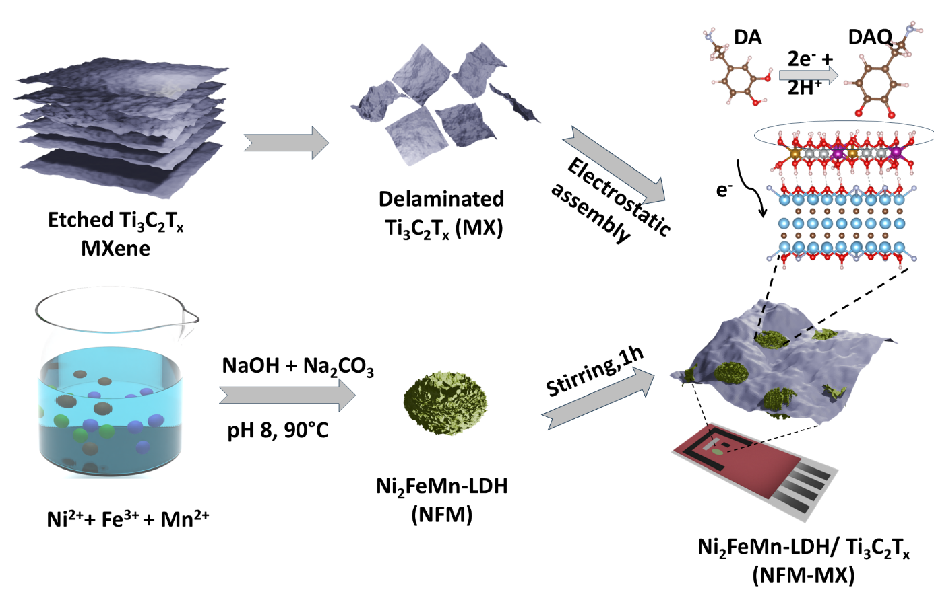
Figure 1. Schematic illustration of the synthesis and dopamine sensing mechanism of the NFM-MX hybrid.

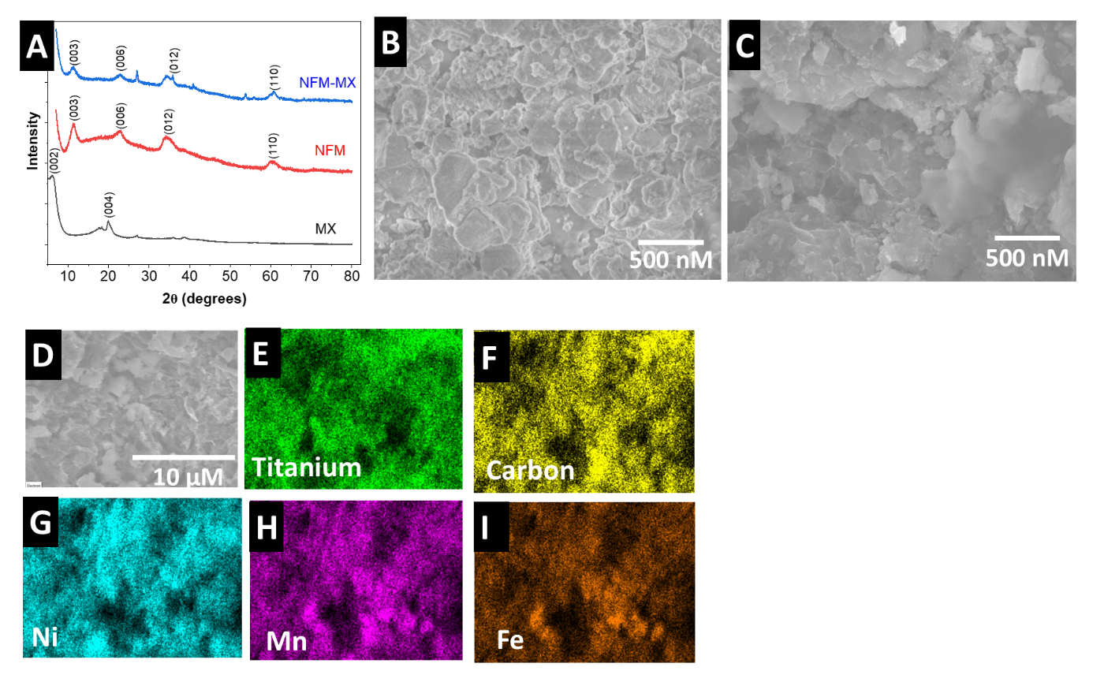
Figure 2. Structural and morphological characterization of MX, NFM-LDH, and NFM-MX. (A) X-ray diffractograms of MX, NFM-LDH, and NFM-MX. The NFM-MX composite shows characteristic LDH reflections indexed to the (003), (006), (012), and (110) planes. Scanning electron micrographs of (B) NFM-LDH and (C) NFM-MX. (D) Scanning electron micrographs of NFM-MX and corresponding EDS elemental maps of (E) Ti, (F) C, (G) Ni, (H) Mn, and (I) Fe, confirming the coexistence and spatial distribution of MXene and NFM-LDH components.

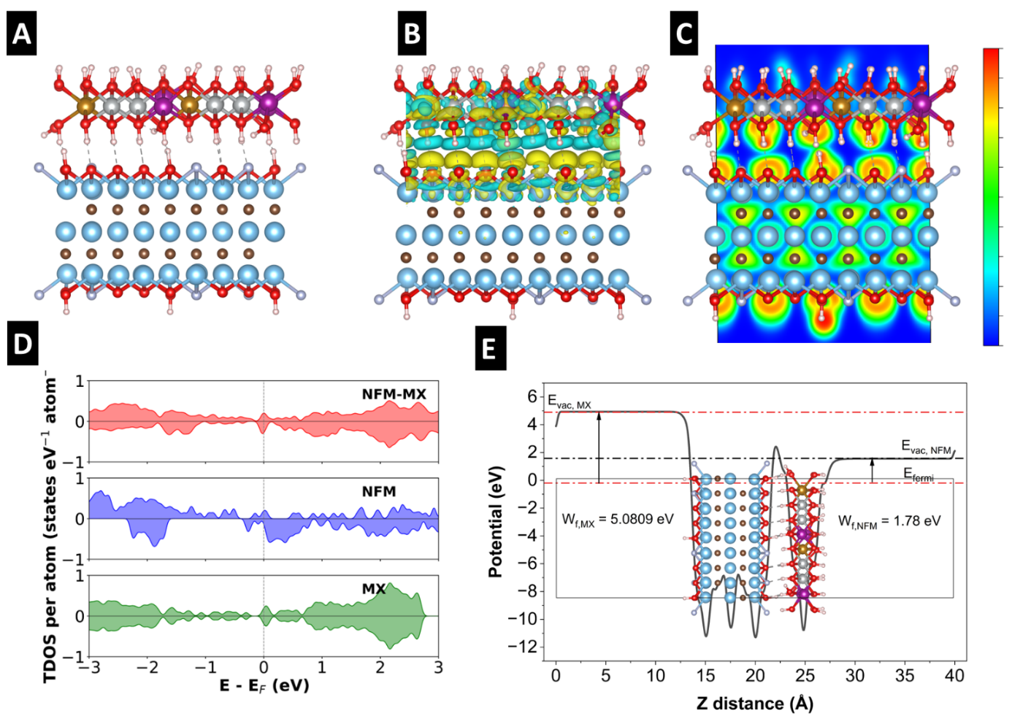
Figure 3. DFT analysis of the interfacial electronic structure of the NFM-MX heterostructure. (A) Optimized atomic structure of NFM-MX. (B) CDD map showing interfacial electron accumulation and depletion at the NFM-MX interface (isosurface = 0.002 eÅ⁻³). Yellow and cyan regions represent electron accumulation and depletion, respectively. (C) Electron localization function (ELF) map of NFM-MX. (D) Total density of states (TDOS) of NFM-MX, NFM-LDH, and MXene, showing enhanced electronic states near the Fermi level in the heterostructure compared with isolated NFM-LDH. (E) Planar-averaged electrostatic potential profile of the asymmetric NFM-MX slab, showing distinct vacuum levels on the MXene and NFM-exposed sides with apparent surface work functions of 5.08 and 1.78 eV, respectively.

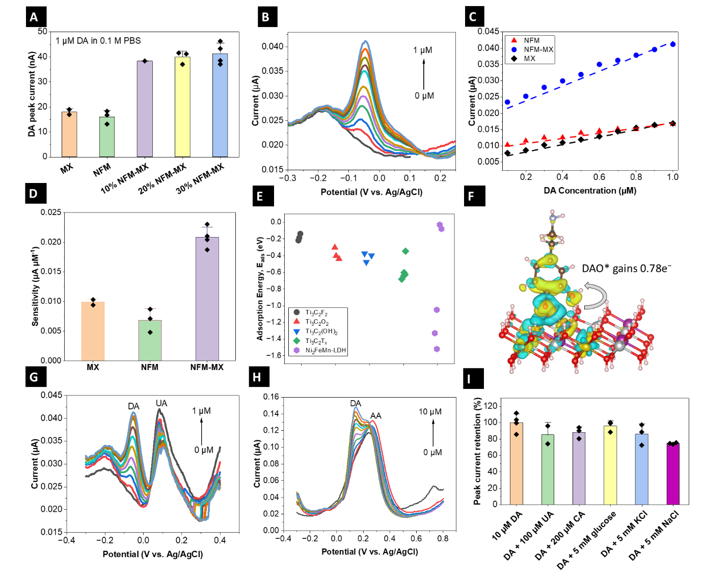
Figure 4. Dopamine sensing performance, selectivity, and mechanistic analysis of NFM-MX electrodes. (A) Optimization of NFM-MX electrode for DA sensing in 0.1 M PBS. (B) DPV response of the optimized NFM-MX electrode toward increasing DA concentrations from 0 to 1 µM. (C) Calibration plots comparing MX, NFM, and NFM-MX electrodes. (D) Sensitivity comparison obtained from the calibration slopes. (E) DFT-calculated adsorption energies (E_{ads}) of DA on different Ti₃C₂ terminations and the NFM surface, dots represent different sites. (F) Charge density difference of DAO* adsorbed on the NFM surface, showing interfacial charge redistribution and electron transfer to DAO*. (G) DPV response of DA(0-1 µM) in the presence of UA(50 µM) (H) DPV response of DA(1-10 µM) in the presence of AA(100 µM), showing partial overlap between DA and AA oxidation features. (I) Normalized DA peak current retention(%) in the presence of common interferents.
Missing: TOC image and TOC text
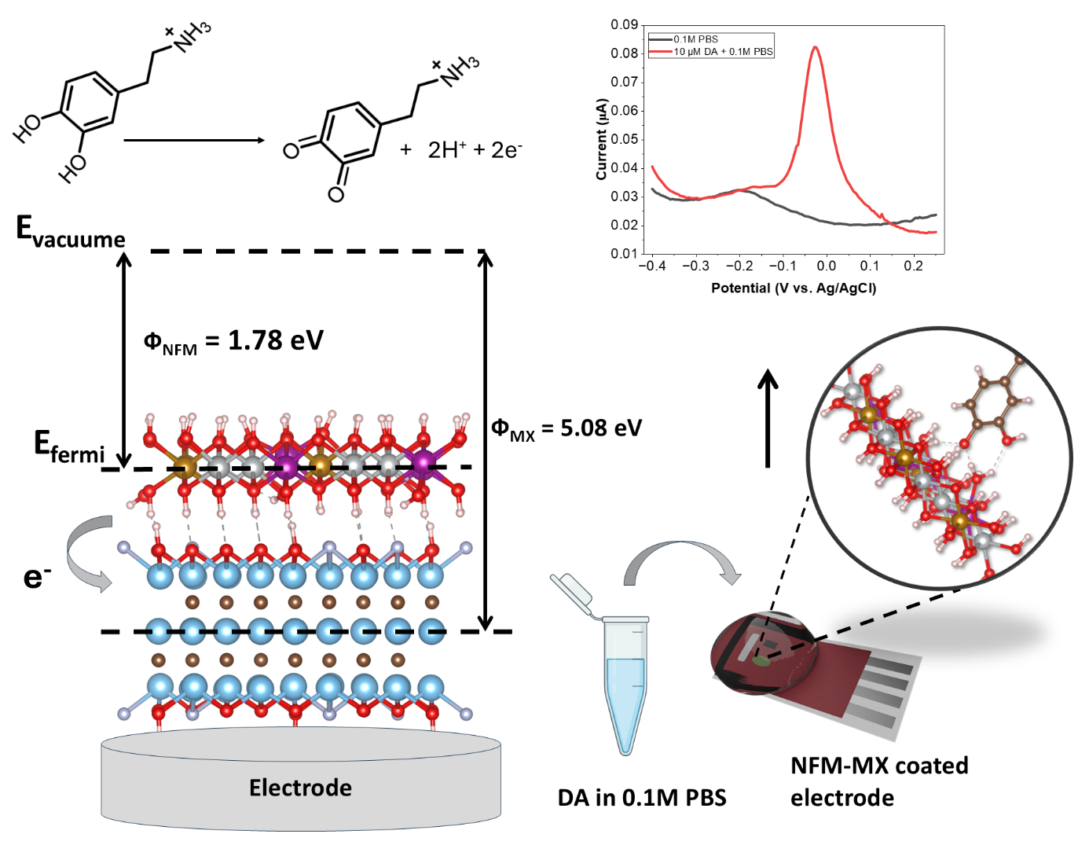
NFM-MX Interface-Driven Dopamine Sensing

